lecture note (dbms2425_selection.pdf) is about query selection strategies in DBMS, focusing on I/O cost estimation and choosing the optimal index when executing selection operations.

1️⃣ Core Concept: Selection in DBMS
In a DBMS, selection (σ) means retrieving rows that match a certain condition from a relation (table).
Example:
σA=10(R)
means: find all tuples in relation R where attribute A=10.
The key question:
What’s the most efficient way to get those tuples from disk?

2️⃣ Notions of Clustering

a) Clustered-file organization
- Rows from different relations stored together in the same blocks, grouped by a shared key value.
- Goal: speed up joins between those relations.

b) Clustered relation (contiguous storage)
- Tuples of the same relation are stored together in contiguous pages.
- Makes full scans more efficient because tuples are in sequence.

c) Clustering index
- An index where tuples with the same key are physically stored together.
- Advantage: Fewer pages to read when many tuples share the same value.
Example:
If R is clustered on A, then all rows with A=5 will be grouped in nearby pages.

3️⃣ Estimating Disk I/O for Selection
The number of disk I/Os depends on:
- Whether the table is clustered or not clustered
- Whether you use an index
- Whether the condition is equality (=) or inequality (<, >, <=, etc.)
- Selectivity: How many rows match the condition.

Case 1: Full table scan
- Clustered table:
Cost = B(R)
(Read all blocks)
- Unclustered table:
Cost=T(R)
(Fetch one block per tuple, worst case, because tuples are scattered.)

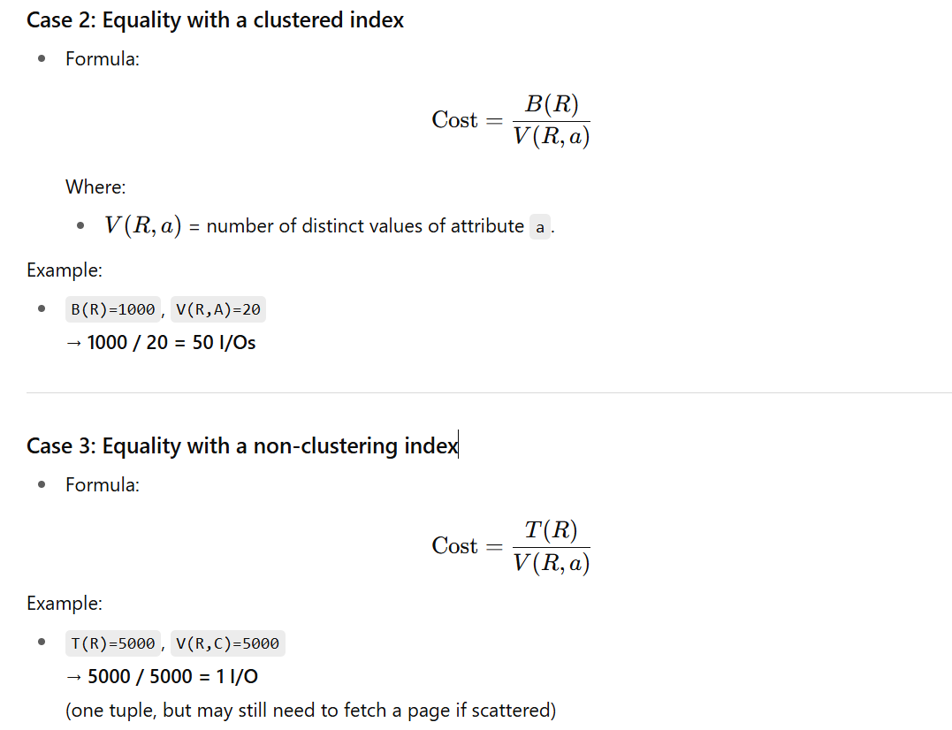

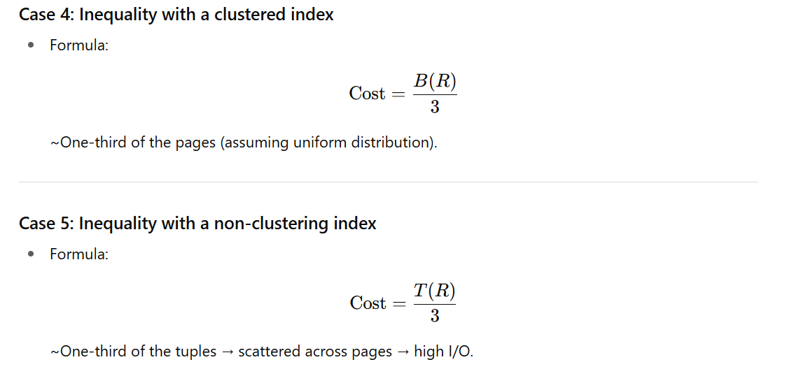

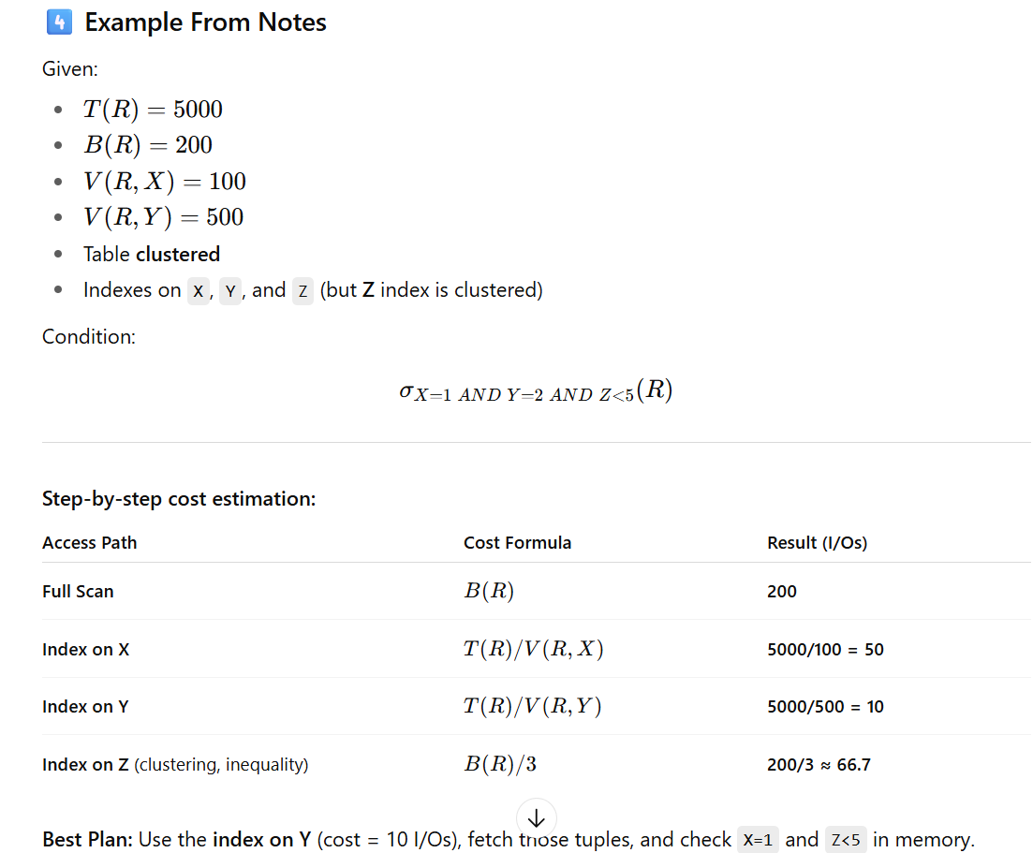

5️⃣ Key Strategy
When multiple indexes exist:
- Estimate I/O cost for each candidate index.
- Choose the most selective (fewest I/Os).
- Apply remaining conditions in memory after fetching candidate tuples.

6️⃣ Real-world analogy
Imagine you have a huge library:
- Clustered shelf: all books by an author grouped together.
- Non-clustered shelf: books scattered randomly.
- Equality search: find one exact title.
- Inequality search: find all books published after 2010.
Using a clustered organization lets you pull books in bulk from one shelf quickly, while non-clustered makes you run around the whole library.

